Assignment – 06

Name – Pankaj Pidurkar

Roll No 86658

User - KD1_Pankaj_86658

Que 1)

Que 2)

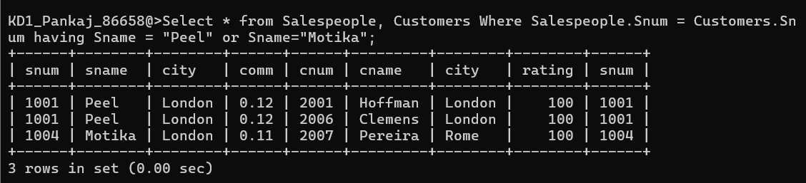

Que 3)

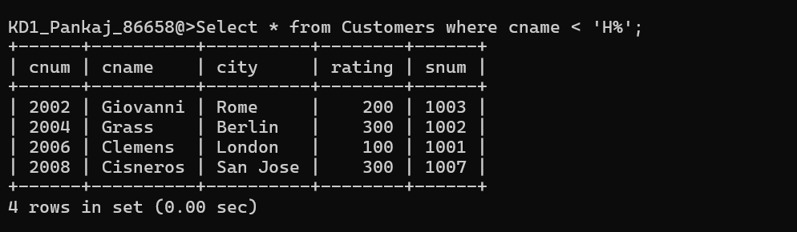

Que 4)

Que 5)